**Duty ID Generator**

***Preference Overview***

If this preference is left unchecked, duties (Driver blocks) in the Driver Gantt will be numbered sequentially from 1.

If the preference is checked, the optimizer will try to number the driver duties so that successive duties using the same vehicle appear consecutively. Here is an example:

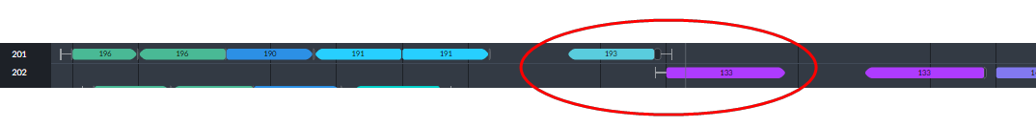

The circled service trips use the same vehicle as shown in their information boxes below:

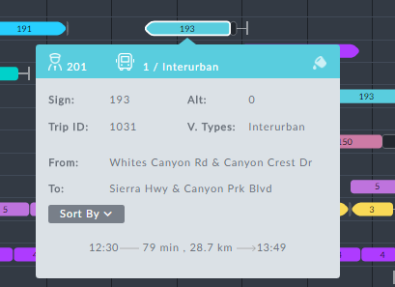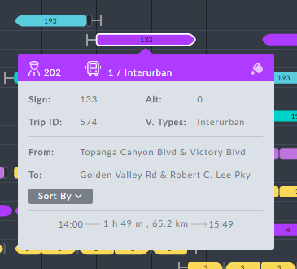

For the moment, there is no baseline preference and there are currently no templates.